APRIL 2006
www.ihbs.org

Calendar of Events

April Meeting

In Memoriam--Carolyn McCoy-Jones

Scientific Analyses in Turkmen Carpet Studies
Lecturer: Jürg Rageth
Time: 3:00 PM
Date: Saturday, April 29, 2006
Location: Capital Hall Auditorium on the Tenley
Campus, American University

(NOTE: THIS IS NOT OUR USUAL LOCATION, DUE TO OTHER CONFERENCES TAKING PLACE ON CAMPUS ON THIS DAY. SEE BELOW FOR TRAVEL DIRECTIONS.)

This talk will describe the identification of different insect dyes using tin mordant, and the way they have been used by the Turkmen of Central Asia. It will explain how these people altered their use over time of insect dyes of different kinds, and how synthetic reds eventually replaced them. This interdisciplinary examination, using dye and mordant analyses in combination with radiocarbon dating, provides new insights into oriental carpet studies. The combination of these three technologies suggests a powerful tool for describing the historic evolution in the use of dyes in textiles generally.

Jürg Rageth is an independent researcher on oriental carpets and textiles. He is based in Riehen, Switzerland. He has been involved with radiocarbon dating since 1995, and published several articles on this subject. This lecture covers part of his recent work for a forthcoming publication on Turkmen carpets of Central Asia. As the head of the Basel rug society “Fruende des Orientteppichs,” he was the organizer of several carpet and textile symposia, which have been published under his imprint.

Directions to Tenley Campus:

The Auditorium is located in Capital Hall, the building at the intersection of Nebraska Avenue and Yuma Street, very close to where they intersect Wisconsin Avenue. (For a campus map, see http://www.american.edu/maps/tenley.htm.)

There is no special parking lot, but STREET PARKING is available in the area on Saturday.

Alternatively, the Tenley Campus is south of the Tenley Metro station (red line), a 5 minute walk away.

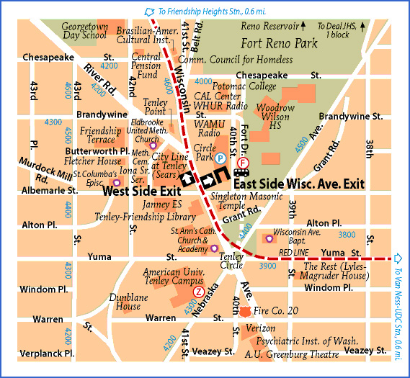

* * * * *

Caroline McCoy-Jones (1917 – 2006)

Caroline McCoy-Jones was a woman of great loyalty and spirit. She was outspoken in her likes and dislikes. She loved animals and textile art. She disliked human puffery and duplicity; she was disinclined to ikats, categorically.

Caroline was a great friend of another IHBS member whom we also lost recently – Mary Hammond Sullivan. These were two indomitable women not willing to cede the rug world to the male of the species. They both took an active role in nurturing young collectors. “Buy the best you can afford,” Caroline would say. Buy the best, be the best. Quality is what really counts.”

Caroline followed her own advice. IHBS members will be familiar with the two stunning Central Asian coats that served as focus for The Textile Museum’s recent Silk and Leather exhibition in Caroline’s honor, curated by John Wertime. Equally fine is the suo, the Japanese Noh costume, donated in 2003, and currently on view at The TM in Director’s Choice. Caroline generously presented these and other objects to The TM, taking pleasure in the art of giving.

Caroline was introduced to the world of textiles through her marriage to H. McCoy Jones, a collector of tribal rugs, who a principal founder of the International Hajji Baba Society and a member of the Board of Trustees of The Textile Museum. At home on Bancroft Place, nearby The TM, and later out on Mass Ave., they drew the young and eager for study and discussion about collecting and collectors. Skilled in culinary matters, Caroline provided sustenance of another sort.

Caroline developed a keen eye for textiles, however, and after McCoy’s death in 1987 took an active role in increasing the range and depth of the McCoy Jones collection which McCoy had given to the Fine Arts Museums of San Francisco in 1980. When the deYoung Museum reopened last October the Department of Textiles was named the Caroline and H. McCoy Jones Department of Textile Arts in recognition of their extraordinary generosity.

It was my pleasure to rekindle Caroline’s interest in The Textile Museum. Caroline was living in Reno when I became Director. Later she moved to Ware Neck, VA and then Richmond. In each location she accommodated the house to herself and her animals (including a donkey, in Reno, and numerous llamas in Ware Neck).

Caroline called me mid-January just two weeks before she became ill. Among other things, we talked about her future plans that might include moving to a retirement community. But first, she wanted to enjoy her garden in its spring bloom. An avid gardener, Caroline loved her daffodils, Asian lilies, iris, Virginia bluebells and her beautiful fringe trees. April/May/June was her favorite time of year.

Ursula E. McCracken
Director of the Textile Museum (1986-2004)

* * * * *

There will be a memorial service for Caroline McCoy-Jones at Oak Hill Cemetery in Washington, DC. In lieu of flowers, her wish was that contributions be made to the Gloucester-Mathews Humane Society, P.O. Box 385, Gloucester, VA 23061, or to the Virginia Living Museum, 524J Clyde Morris Blvd., Newport News, VA 23601.

